**Screen Shots on Errors**

**Pdfgenerator page:**

1. When page loads in chrome, the page is appearing as like below image. Here it is not showing chart. It is asking to “load unsafe script”.

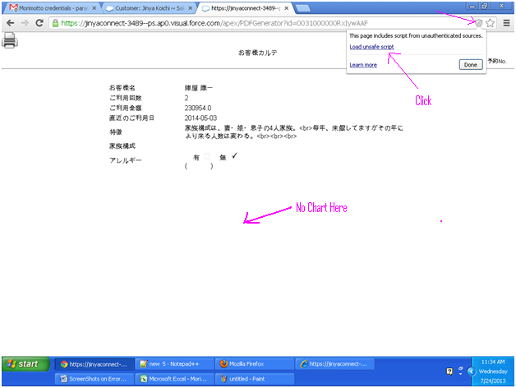

1. Chrome: Click on Load unsafe script as shown in above image, th page will show up as below with chart and observe the Url “https” is crossed marked with red lines.

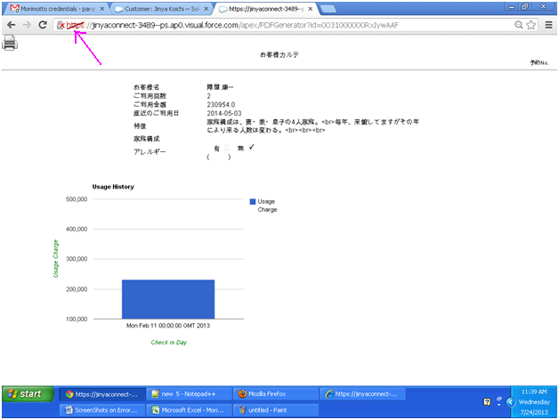

1. IE : When page loads, it is showing security message in IE as like below image.

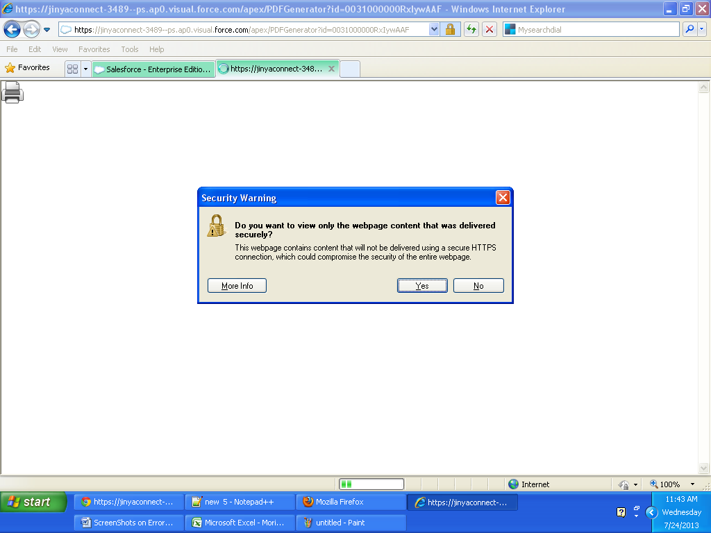

1. IE: if click on “Yes” in the security message, the page will show up as like below image without chart. If click on “No” on security message, it will show up the page with chart correctly.

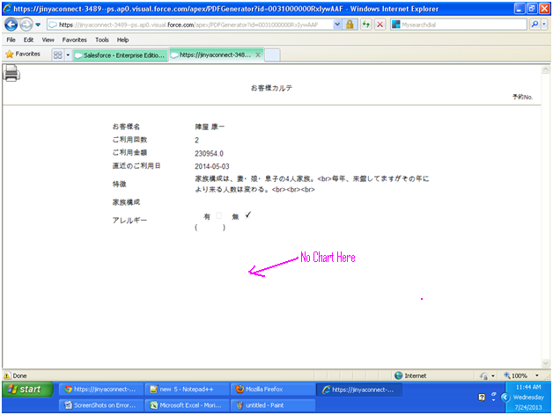

**Customer Standard detail view:**

1. IE: Observe in below image of Customer Detail view page, In the Barcode section, the barcode lines are not displaying.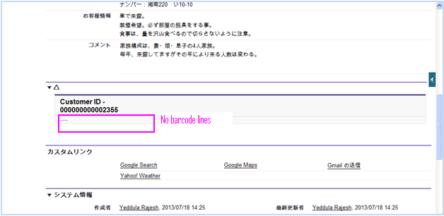

**RoomIndicatorInfo Page:**

1. Chrome & Mozilla : On loading the RoomIndicatorInfo page

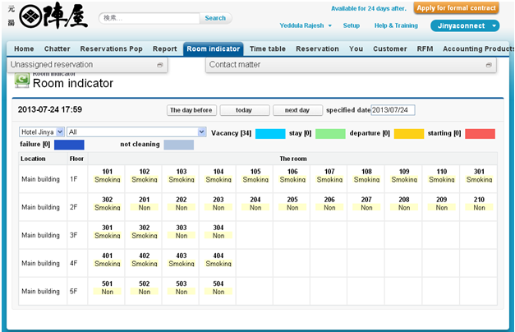In IE: On loading the RoomIndicatorInfo page see below Image no unassigned tab and Contact matter on the top of page. Below of the page is showing extra fields data.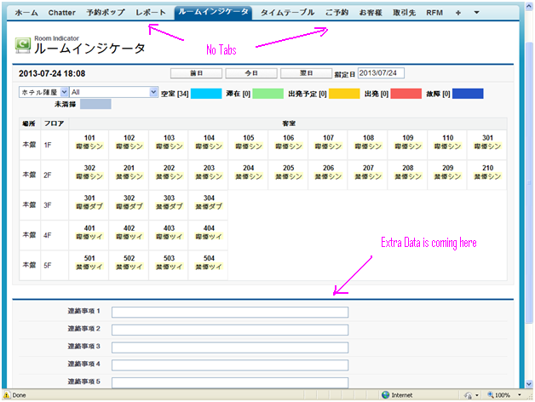

1. In IE: On selected date

Here it is allows to change the date through key board and also from calendar. Whereas in chrome and Firefox its not allowing to enter through keyboard.

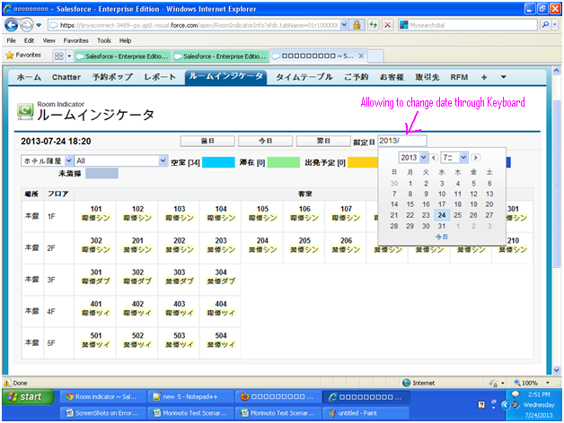

**Bulk Reservation:**  In chrome and Firefox: while Reservation number is given on page, automatically data is filled up.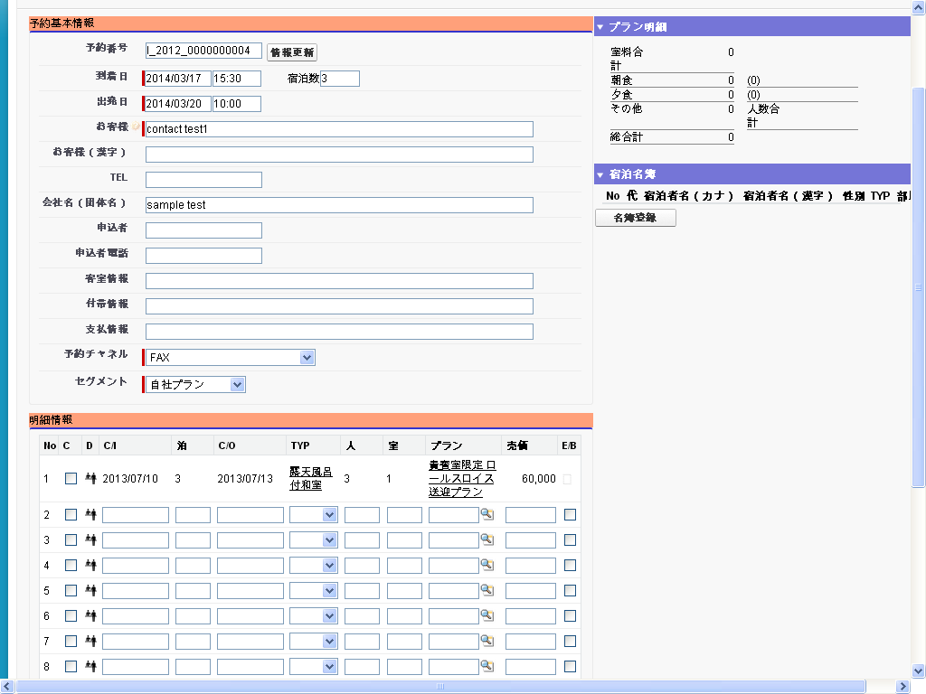

IE: In IE the auto complete and auto filling data below is not populating automatically. Where as in chrome and Firefox, it is working . Compare this image with above image.

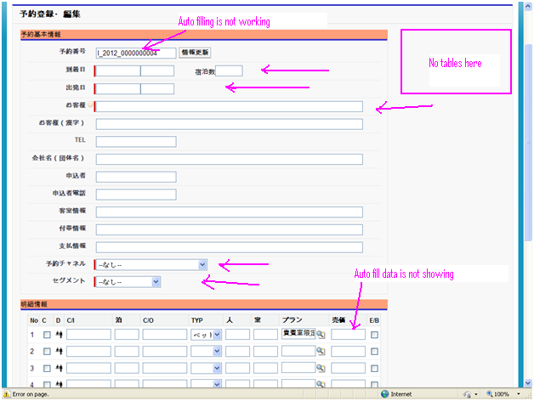

**Chrome:**  while selecting Reservation numbers from auto complete. After selecting one number it will show up related values automatically, but still auto complete popup is showing after selected also. See below image.

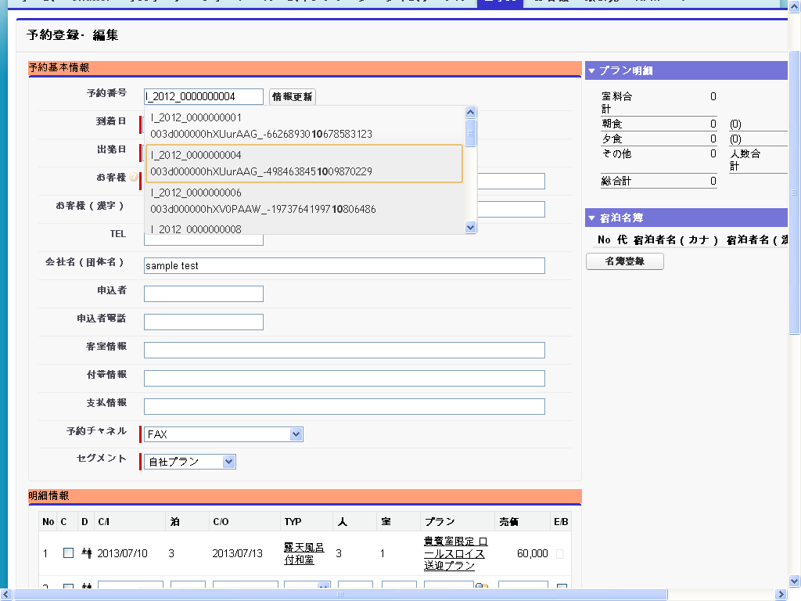

**Chrome:** From the above image, from popup I changed the reservation number, but still it is showing data of previous reservation number data.

